Supplementary Material

Sup. Table 1: Average and range pairwise sequence identity percentage of the different groups obtained from the circular cladogram presentation of the phylogenetic analysis.

Sup. Fig. 1: Atom labeling for the FAD (left) and NADPH (right) cofactors. Visualization done with PyMol software.

Sup. Table 2: Amino acid positions of the multiple sequence alignment that are conserved in more than 70% of the sequences.

Sup. Table 1: Average and range pairwise sequence identity percentage of the different groups obtained from the circular cladogram presentation of the phylogenetic analysis.

Groups | Average sequence identity | Sequence identity range
Red | 49.5 | 36 – 89
Blue | 52.6 | 43 – 87
Green | 53.9 | 43 – 88
Red-Blue | 26.4 | 20 – 34
Red-Green | 44.1 | 34 – 60
Blue-Green | 27.4 | 20 – 34

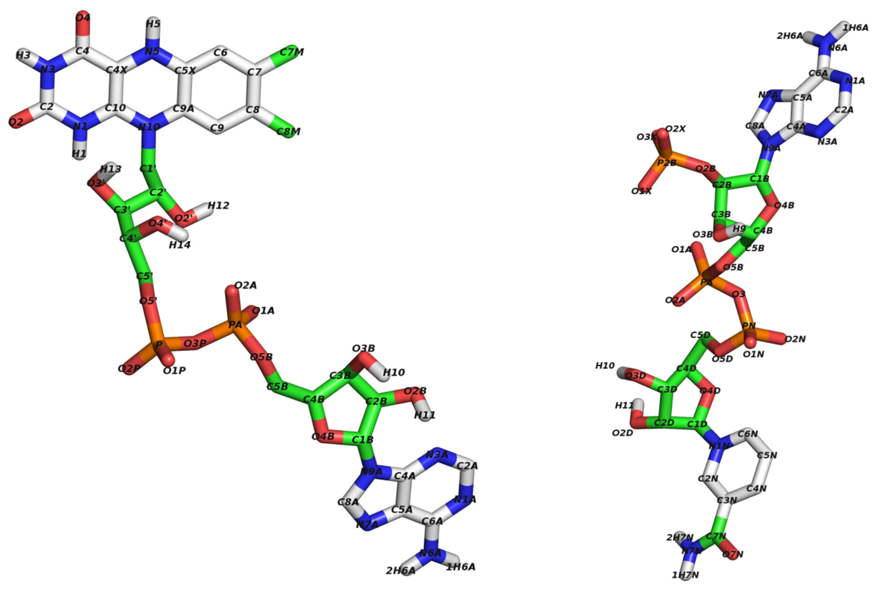
Sup. Fig. 1: Atom labeling for the FAD (left) and NADPH (right) cofactors. Visualization done with PyMol software.

